**Scripting Task**

**Task Description:**

1. Create a shell script to print the HTTP error code of guvi.in & print, the success/failure message based on the error code response

#!/bin/bash

response=$(curl -s -o /dev/null -w "%{http_code}" https://www.guvi.in)

echo " HTTP status code is: $response"

if [ "$response" -ge 200 ] && [ "$response" -lt 300 ];

then

echo " Success "

else

echo " Failure "

fi

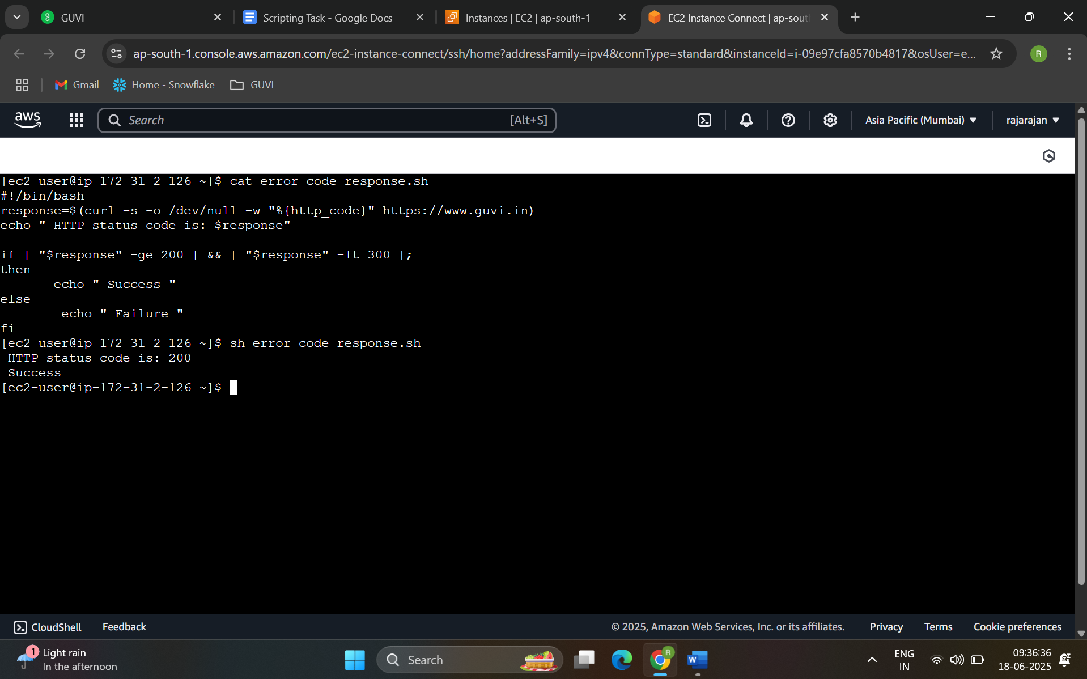

1. Given a file, replace all occurrence of the word "give" with "learning" from 5th line till the end in only those lines that contain the word "welcome"

[ec2-user@ip-172-31-2-126 ~]$ cat task2.txt

Line one

Line two

Line three

Line four

Welcome and give your best

Just welcome

We will give our best

Welcome to the team, give it your all

[ec2-user@ip-172-31-2-126 ~]$ vi task2.sh

[ec2-user@ip-172-31-2-126 ~]$ cat task2.sh

awk 'NR<5 {PRINT} NR>=5 && /Welcome/ {$0=gensub(/give/, "learning", "g")} {print}' task2.txt > outputtask2.txt

[ec2-user@ip-172-31-2-126 ~]$ sh task2.sh

[ec2-user@ip-172-31-2-126 ~]$ cat outputtask2.txt

Line one

Line two

Line three

Line four

Welcome and learning your best

Just welcome

We will give our best

Welcome to the team, learning it your all

[ec2-user@ip-172-31-2-126 ~]$

